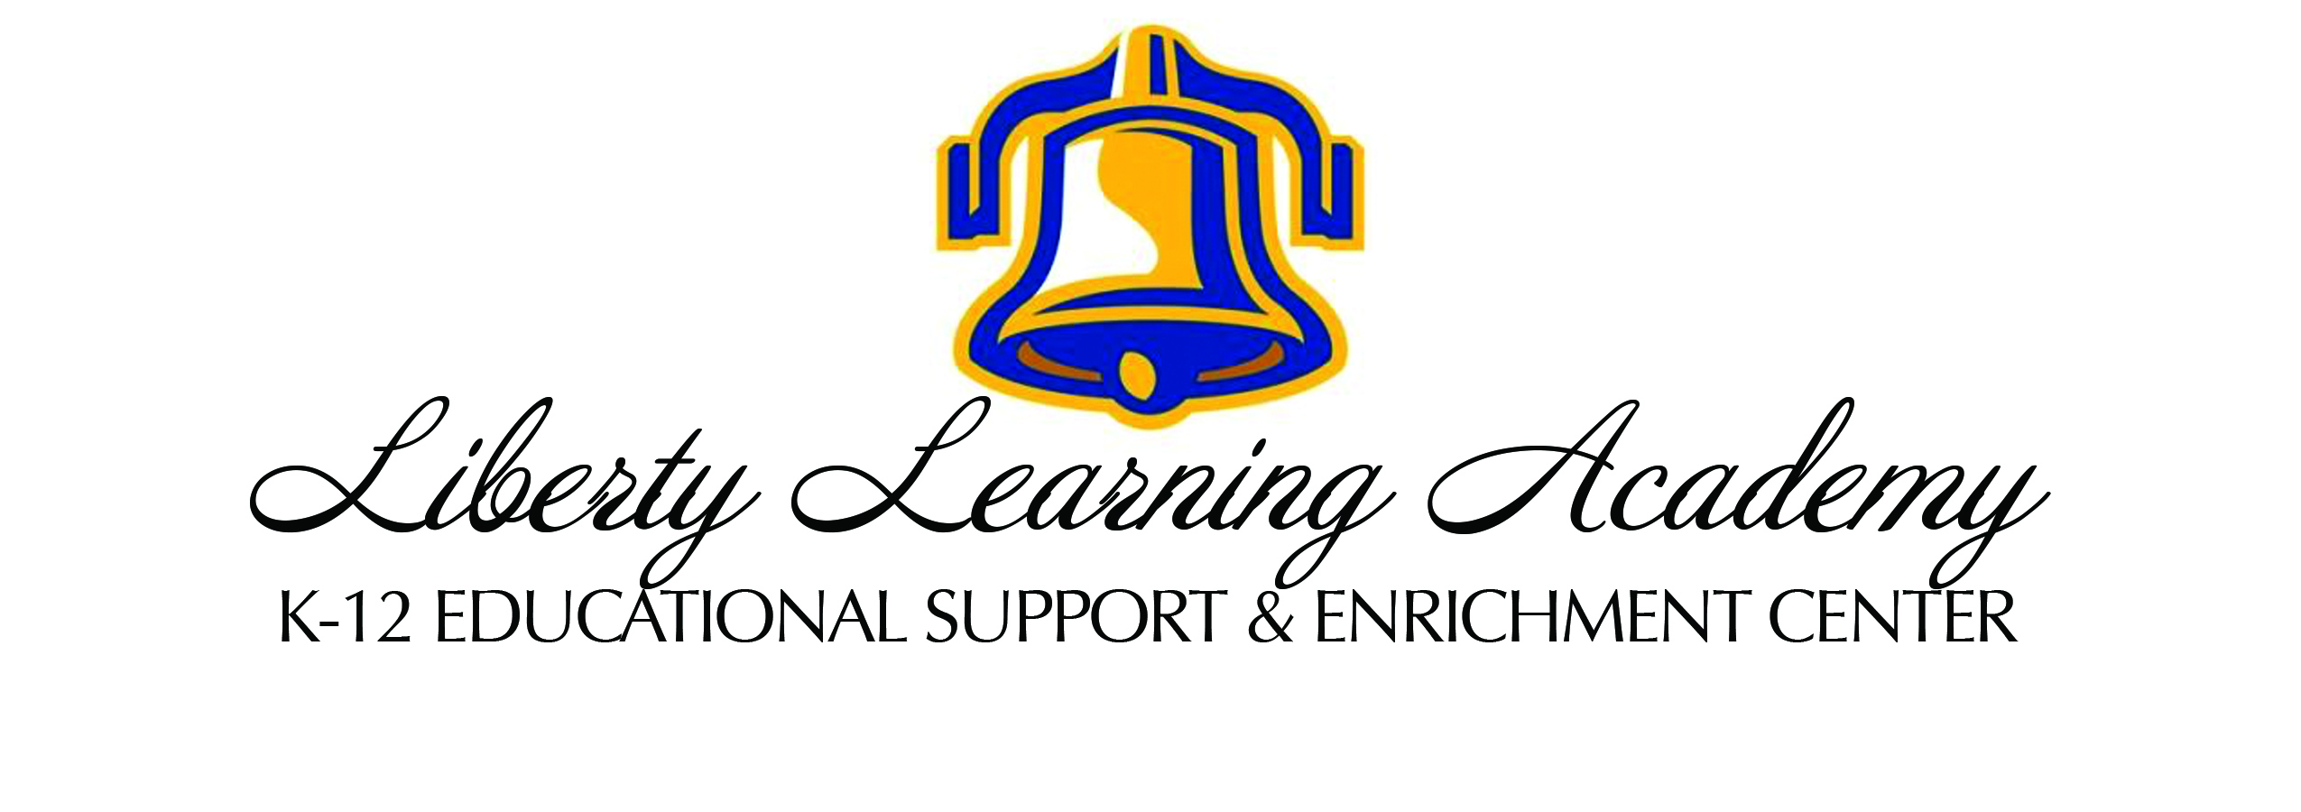

2023-2024
Parent Student Handbook

Updates and revisions may be made to this handbook at the administration’s discretion.

WELCOME!

Registration Fees:

Registration fees are as follows, per enrolled student, and must be paid in full in order to reserve a space in a class and prior to the beginning of classes. A discount maybe offered for early registration.

- $65 nonrefundable registration fee (2nd child $55, 3rd + child $50)
- $5 per class fee

Class Fee Refund Policy:

Within the first two weeks of courses, class fees are refundable if:
- classes are cancelled due to low enrollment
- class teacher is changed and you want to drop (drop form req)
- schedule change doesn’t work for you

*If these fees impose a hardship on your family, please contact our administration for alternative options. We never want to turn away students due to cost.

Parent Requirements:

- Parents must fill out a registration form which includes emergency medical and contact information for each student they are enrolling.
- Parents must print, sign, and return a hard copy of the release of liability waiver form. This form must be turned in on or before the first day of classes.
- Parents must request teacher of each class as a vendor through their charter school if they plan to use educational funds for payment. They must follow necessary steps through their charter school to ensure teacher is paid as a vendor. Purchase orders must be issued before the start of classes. If your charter school fails to pay, parent will be responsible for class fee.
- If you are paying with cash, payment must be received before the start of classes.
- Students are expected to arrive on time to avoid disruption to class
- If you need to miss class, please make arrangements with the teacher to get missed work

Service Request:

Each family is requested but not required to serve/volunteer on campus. The blessings and benefits of our program comes with the responsibility of stewardship that we cannot manage without you! Your support is vital for us to continue providing this service.

The following requests are per semester:

- Each registered class = 1 hour of service (i.e. math = 1hr, ELA = 1hr etc)
- The maximum request is 9 hours per family

Families may donate $20/class instead of volunteering service but we prefer and need to help as the first option.

A list of volunteer opportunities will be sent via email for signup.com.

Before/After Hours Guidelines:

- There is no supervision available before or after classes with the exception of lunch time. Students should arrive no earlier than 10 minutes before a class and be picked up no later than 10 minutes after a class ends. Students left longer than 10 minutes after a class will incur a $20 charge per student for each ½ hour or portion thereof.
- Students are not permitted to play in the play yard before or after classes without direct parental supervision.

Lunch:

*Lunch period is 30 minutes long (from 12:00 – 12:30). It is a closed campus for student in grades TK-6. They will not be permitted to leave unless with a parent or designated adult. For students in grades 7-12 it is an open campus. If you wish for your student to stay at the campus they are welcome to eat their lunch in the common area or outside. There will be supervision for all grade levels provided by parent, teacher and community volunteers.

Students are expected to clean up after themselves and dispose of their trash before returning to class. Please clearly mark all lunch boxes, bags, backpacks, etc. with your child’s name. You may want to send a water bottle with your child as we do not have a drinking fountain or water dispenser.

*We plan to be able to have pizza for sale on Thursdays. We also plan to have a snack bar available for all ages.

Student Responsibilities:

We believe students learn and grow most effectively in an environment that cultivates honor. We model this trait by treating students, teachers, and administrators with respect at all times and insisting that our student population do the same.

No unwanted physical contact or disrespectful behavior between students will be tolerated. Students, teachers and parents are expected to use honorable and kind language while on campus refraining from using hurtful and belittling words. Cursing, foul jokes, and bad language will not be tolerated. Again, we expect our students to be respectful to their peers, their teachers, and the administration. In the event we do experience a problem at our center, an incident form should be completed by the teacher or parent that was witness to it and parents will be notified.

Students are expected to participate fully in class, return homework assignments in a timely manner, and comply with the requests and requirements of teachers and administrators.

Dress Code:

The purpose of establishing a dress code for LLA is to cultivate a learning environment of honor, respect, and modesty on our campus. We desire that our community demonstrate excellence, self-worth, and value of others in their clothing choices.

The following are guidelines that will be enforced at the discretion of the LLA administrators and teachers:

● Any shirt, sweatshirt, hoodie, or hat that states a message must be
neutral and not derogatory, blasphemous, or dishonoring of any person
or group.
● Clothing that reveals midriff or cleavage should not be worn on
campus.
● Shirts, tops, and dresses must have straps that are the width of 2 or more
fingers or an over shirt or sweater should be worn. No strapless tops or
dresses.
● Dresses and skirts worn without leggings must reach to the mid-thigh or
below. ● Shorts should be well fitting (not overly tight or loose) with no
undergarments showing. Shorts should come to the mid-thigh or below.
● Pants should be well fitting. No undergarments should show through
tears or holes in pants.
● Sheer clothing must have a suitable undergarment (tank top or cami)
underneath.
● Footwear must be worn on campus at all times.
If students are found in violation of the dress code parents may be called to bring a change of clothing to campus.

Technology Policy:

Cell phone/tablet usage while on campus is prohibited unless permitted by the teacher for a specific task. To minimize distractions, cell phones/tablets should be stored away while on campus in purses, book bags, or backpacks. Some classrooms have also implemented a pouch system where students are asked to place their cell phones in the pocket of a pouch hanging in the classroom for the duration of the class. If a student is using a cell phone/tablet without instructor permission while on campus, teachers will ask for the device to be put away and then student does not teachers may confiscate the device until the end of the class. Technology and/or content checks may also be enforced by teachers or administrators while on campus. Liberty Learning Academy assumes no responsibility for students who abuse the technology policy.

Campus Stewardship Requirements:

Honor for our campus and community are expected for all who participate with Liberty Learning Academy. While on campus, please be respectful of the building, parking lot and grounds. No harmful words or actions will be tolerated and students unable to manage their behavior may be asked to leave campus or be disenrolled from the program. Our community works together with our landlord and the other shopping center tenants and desires to meet or exceed the standards and expectations they set for us.

● No Weapons of any kind are allowed on campus. Knives may not be
worn or brought onto campus grounds.

● Drugs, Alcohol, Tobacco, vaping devices and/or e-cigarettes are not permitted on campus.

● Any students known to possess, use, sell, or share these items while on
the LLA grounds or classrooms, may have their registration revoked
immediately.

The LLA Administrators are here to support everyone participating on our campus, including students, parents, and teachers. We are here to serve our community to the best of our ability. If at any time you or anyone on our campus is struggling with an issue, or needs help with a problem, please let us know.

